LAB 06
Analogue to Digital Conversion (ADC)



Spring 2026
CSE-420L Embedded Systems LAB

Submitted By: Naveed Ahmad
Registration No: 22PWCSE2165
Section: B

“On my honor, as student of University of Engineering and Technology, I have neither given nor received unauthorized assistance on this academic work”

Submitted to:
Engr. Muhammad Shahzad
May 3, 2026

Department of Computer Systems Engineering
University of Engineering and Technology Peshawar
ADC:
ADC is the process of converting a continuous physical quantity (analog signal) into a digital representation (binary numbers). This process is governed by the Nyquist-Shannon Sampling Theorem, which states that to perfectly reconstruct an analog signal, you must sample it at a rate f_s at least twice as high as the highest frequency component present in the signal fmax
f_s > 2 fmax
If this condition is not met, aliasing occurs, where high-frequency components appear as lowfrequency artifacts in the sampled data.
Stages of Conversion
The conversion process typically involves three distinct stages:
- Sampling: Converting a continuous-time signal into a discrete-time signal by taking periodic "snapshots" of the amplitude at specific time intervals T_s = 1/f_s.
- Quantization: Mapping the infinite range of possible analog amplitudes to a finite set of discrete levels. Each level is determined by the ADC's resolution.
- Encoding: Assigning a unique binary code to each quantized level.
Common ADC Architectures
Depending on your lab equipment, you are likely using one of these common topologies:
- Flash ADC: Extremely fast but hardware-intensive (uses 2^n - 1 comparators). Best for high-speed applications.
- Successive Approximation Register (SAR) ADC: A balanced approach that uses a binary search algorithm to arrive at the digital value. It is the most common architecture for general-purpose microcontrollers.
- Delta-Sigma ADC: Uses oversampling and noise shaping. It provides very high resolution and is commonly used in high-fidelity audio applications.
TASK:1
Read Anaolgue value using potentiometer and display ADC value on serial monitor.
CODE:
#include <avr/io.h>
#include <stdio.h>
#include <util/delay.h>

// Initialize USART for Serial communication at 9600 baud void USART_init(void) {
UBRR0H = 0;
UBRR0L = 103; // For 16MHz clock and 9600 baud
UCSR0B = (1 << TXEN0); // Enable Transmitter
UCSR0C = (1 << UCSZ01) | (1 << UCSZ00); // 8-bit data
}

// Send a character over USART void USART_transmit(char data) { while (!(UCSR0A & (1 << UDRE0)));
UDR0 = data;
}

// Initialize ADC void ADC_init(void) {
// AREF = AVcc
ADMUX = (1 << REFS0);
// Enable ADC, set Prescaler to 128 (16MHz/128 = 125kHz)
ADCSRA = (1 << ADEN) | (1 << ADPS2) | (1 << ADPS1) | (1 << ADPS0);
}

// Read ADC value uint16_t ADC_read(uint8_t ch) {
ADMUX &= 0xF0; // Clear previous channel
ADMUX |= ch; // Select new channel ADCSRA |= (1 << ADSC); // Start conversion while (ADCSRA & (1 << ADSC)); // Wait for conversion to complete return ADC; // Return 10-bit result
}

int main(void) {
USART_init();
ADC_init();

char buffer[10];

while (1) { uint16_t adc_val = ADC_read(0);

// Convert integer to string and transmit sprintf(buffer, "%d\r\n", adc_val); for(int i = 0; buffer[i] != '\0'; i++) {
USART_transmit(buffer[i]);
}

_delay_ms(500);
}
}
OUTPUT:
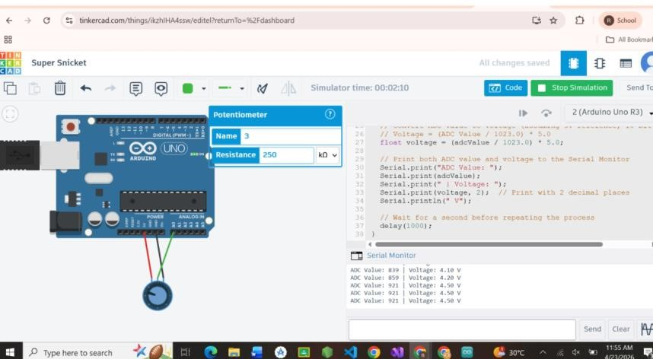
TASK:2
Control LED brightness based on sensor i/p(use hardware registers)
CODE:
#include <avr/io.h>

// Initialize ADC for 10-bit resolution void ADC_init(void) {
// REFS0: Set Reference Voltage to AVcc (5V)
// The MUX bits are left at 0 to select ADC Channel 0 (PC0)
ADMUX = (1 << REFS0);

// ADEN: Enable ADC
// ADPS2, ADPS1, ADPS0: Set Prescaler to 128 (16MHz/128 = 125kHz ADC clock)
ADCSRA = (1 << ADEN) | (1 << ADPS2) | (1 << ADPS1) | (1 << ADPS0); }

// Read from the currently selected ADC channel uint16_t ADC_read(void) {
ADCSRA |= (1 << ADSC); // Set ADSC bit to start the conversion while (ADCSRA & (1 << ADSC)); // Wait until ADSC clears (conversion complete) return ADC; // Return the 10-bit ADC result
}

// Initialize Timer1 for 10-bit Fast PWM void PWM_init(void) {
// Set PB1 (Pin 9 on Arduino Uno) as an output pin
DDRB |= (1 << PB1);

// TCCR1A Settings:
// COM1A1 = 1, COM1A0 = 0: Clear OC1A on Compare Match, set OC1A at BOTTOM (Noninverting mode)
// WGM11 = 1, WGM10 = 1: Fast PWM, 10-bit mode
TCCR1A = (1 << COM1A1) | (1 << WGM11) | (1 << WGM10);

// TCCR1B Settings:
// WGM12 = 1: Completes the 10-bit Fast PWM mode selection
// CS11 = 1, CS10 = 1: Set clock prescaler to 64 (Yields a PWM frequency of ~244 Hz at 16MHz) TCCR1B = (1 << WGM12) | (1 << CS11) | (1 << CS10);

// Initialize Output Compare Register (Duty Cycle) to 0
OCR1A = 0;
}

int main(void) { ADC_init();
PWM_init();

while (1) {
// 1. Read the 10-bit value from the sensor (0 to 1023) uint16_t sensor_val = ADC_read();

// 2. Write the 10-bit value directly to Timer1's Compare Match register
// A value of 0 means 0% duty cycle (LED off)
// A value of 1023 means 100% duty cycle (LED fully on)
OCR1A = sensor_val;
}
}
OUTPUT:

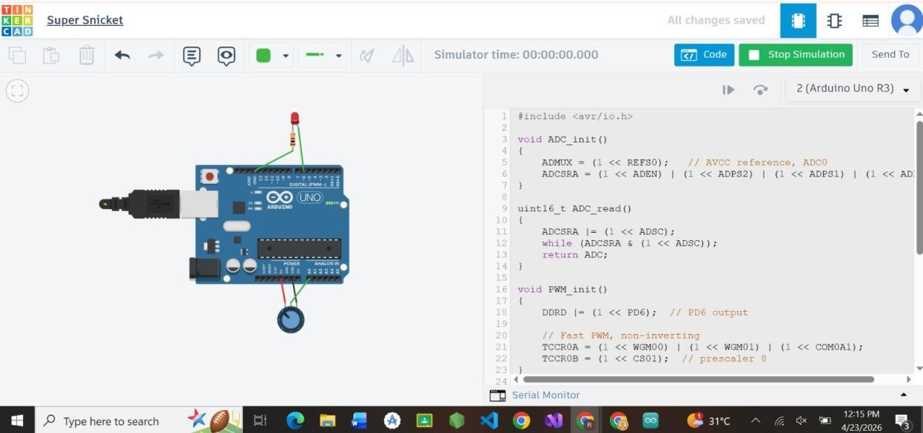

Conclusion:
This lab successfully demonstrated the integration of Analoge-to-Digital Conversion (ADC) and Pulse
Width Modulation (PWM) using AVR hardware registers. By interfacing a potentiometer with the ATmega328P, we effectively transformed continuous analog signals into 10-bit digital values, verifying the process through serial monitoring. Furthermore, applying these digital values to control LED brightness showcased a practical application of data acquisition and hardware control, reinforcing the importance of sampling rates, resolution, and register-level programming in embedded systems design.

